**IBM Cloud Services**

|  |  |
| --- | --- |
| Team ID | PNT2022TMID33042 |
| Project Name | IOT-Smart farmer |
| Maximum Marks | 4 Marks |

**IBM Dashboard :**

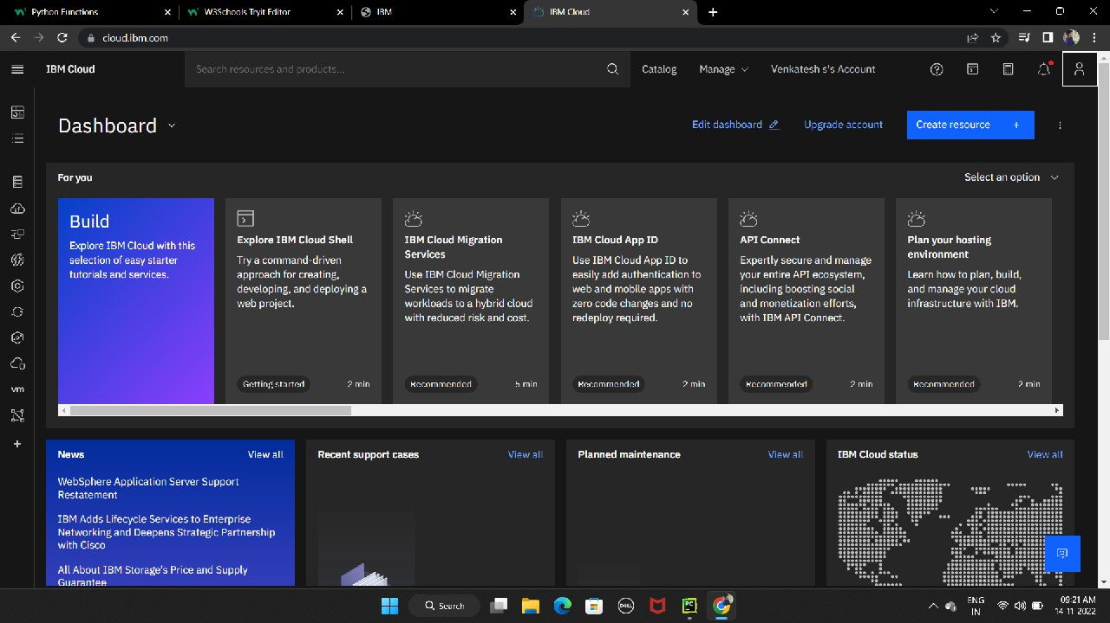

IBM Watson services :

